Screenshots: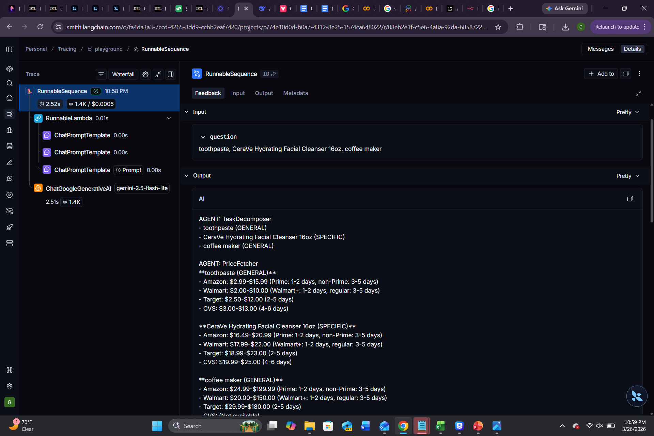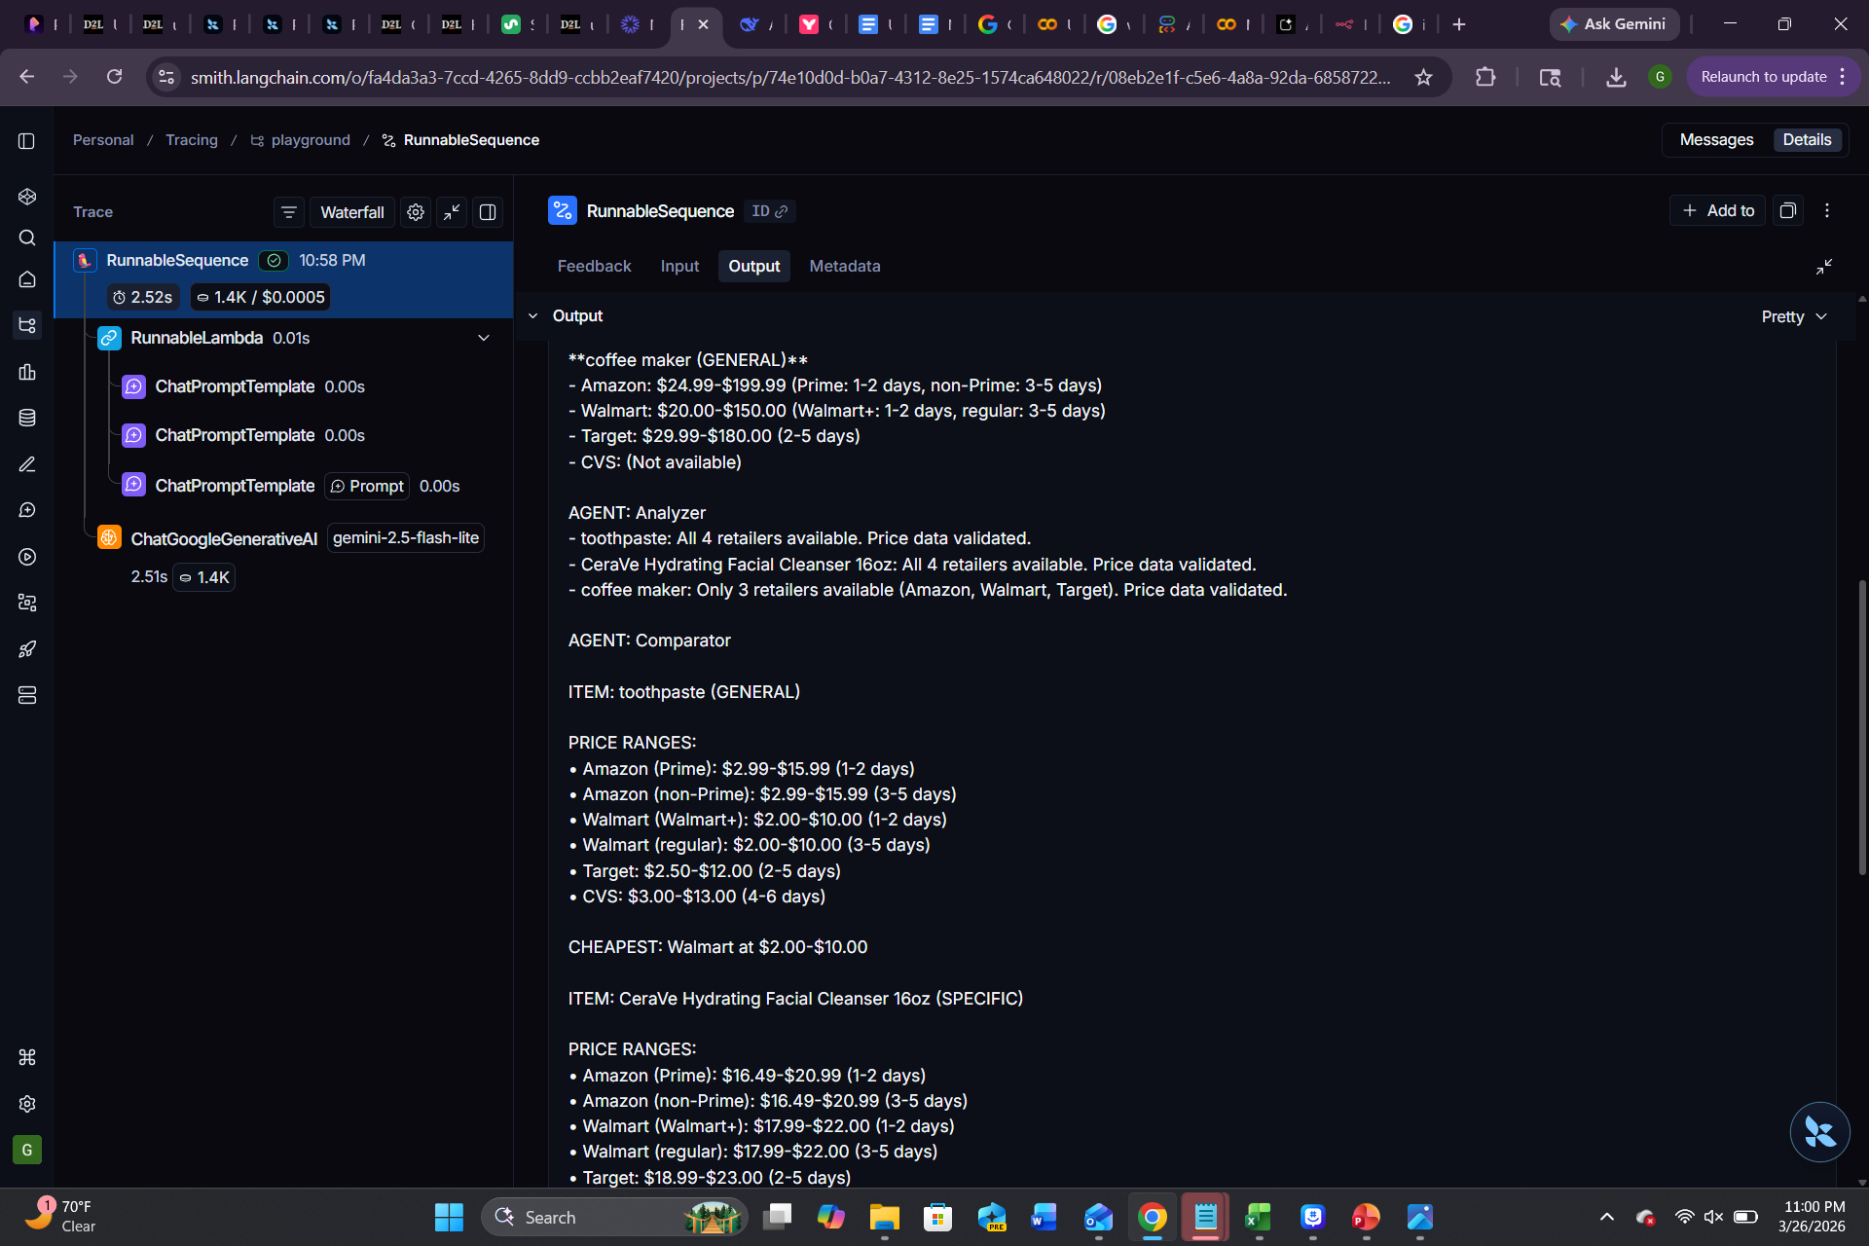

Full Output:
AGENT: TaskDecomposer
- toothpaste (GENERAL)
- CeraVe Hydrating Facial Cleanser 16oz (SPECIFIC)
- coffee maker (GENERAL)

AGENT: PriceFetcher
**toothpaste (GENERAL)**
- Amazon: $2.99-$15.99 (Prime: 1-2 days, non-Prime: 3-5 days)
- Walmart: $2.00-$10.00 (Walmart+: 1-2 days, regular: 3-5 days)
- Target: $2.50-$12.00 (2-5 days)
- CVS: $3.00-$13.00 (4-6 days)

**CeraVe Hydrating Facial Cleanser 16oz (SPECIFIC)**
- Amazon: $16.49-$20.99 (Prime: 1-2 days, non-Prime: 3-5 days)
- Walmart: $17.99-$22.00 (Walmart+: 1-2 days, regular: 3-5 days)
- Target: $18.99-$23.00 (2-5 days)
- CVS: $19.99-$25.00 (4-6 days)

**coffee maker (GENERAL)**
- Amazon: $24.99-$199.99 (Prime: 1-2 days, non-Prime: 3-5 days)
- Walmart: $20.00-$150.00 (Walmart+: 1-2 days, regular: 3-5 days)
- Target: $29.99-$180.00 (2-5 days)
- CVS: (Not available)

AGENT: Analyzer
- toothpaste: All 4 retailers available. Price data validated.
- CeraVe Hydrating Facial Cleanser 16oz: All 4 retailers available. Price data validated.
- coffee maker: Only 3 retailers available (Amazon, Walmart, Target). Price data validated.

AGENT: Comparator

ITEM: toothpaste (GENERAL)

PRICE RANGES:
• Amazon (Prime): $2.99-$15.99 (1-2 days)
• Amazon (non-Prime): $2.99-$15.99 (3-5 days)
• Walmart (Walmart+): $2.00-$10.00 (1-2 days)
• Walmart (regular): $2.00-$10.00 (3-5 days)
• Target: $2.50-$12.00 (2-5 days)
• CVS: $3.00-$13.00 (4-6 days)

CHEAPEST: Walmart at $2.00-$10.00

ITEM: CeraVe Hydrating Facial Cleanser 16oz (SPECIFIC)

PRICE RANGES:
• Amazon (Prime): $16.49-$20.99 (1-2 days)
• Amazon (non-Prime): $16.49-$20.99 (3-5 days)
• Walmart (Walmart+): $17.99-$22.00 (1-2 days)
• Walmart (regular): $17.99-$22.00 (3-5 days)
• Target: $18.99-$23.00 (2-5 days)
• CVS: $19.99-$25.00 (4-6 days)

CHEAPEST: Amazon at $16.49-$20.99

ITEM: coffee maker (GENERAL)

PRICE RANGES:
• Amazon (Prime): $24.99-$199.99 (1-2 days)
• Amazon (non-Prime): $24.99-$199.99 (3-5 days)
• Walmart (Walmart+): $20.00-$150.00 (1-2 days)
• Walmart (regular): $20.00-$150.00 (3-5 days)
• Target: $29.99-$180.00 (2-5 days)
• CVS: (Not available)

CHEAPEST: Walmart at $20.00-$150.00

SUMMARY:
• Items compared: 3
• Best store overall: Walmart

Updated Prompt:
You are a multi-agent shopping assistant system with 4 agents working in sequence.

Process this shopping list: "toothpaste, CeraVe Hydrating Facial Cleanser 16oz, coffee maker"

Run as these 4 agents:

AGENT: TaskDecomposer
Parse the list into individual items and classify each as GENERAL or SPECIFIC.

AGENT: PriceFetcher
For each item, get price ranges from Amazon, Walmart, Target, and CVS.
For Amazon and Walmart, show TWO delivery estimates:
- With membership (Prime/Walmart+): 1-2 days
- Without membership: 3-5 days
For Target and CVS: show standard delivery (2-5 days and 4-6 days)

AGENT: Analyzer
Validate all price data. Flag if any item has less than 2 retailers.

AGENT: Comparator
Find the cheapest retailer for each item. Format the final output.

OUTPUT FORMAT:
ITEM: [product] (SPECIFIC/GENERAL)

PRICE RANGES:
• Amazon (Prime): $XX.XX-$XX.XX (1-2 days)
• Amazon (non-Prime): $XX.XX-$XX.XX (3-5 days)
• Walmart (Walmart+): $XX.XX-$XX.XX (1-2 days)
• Walmart (regular): $XX.XX-$XX.XX (3-5 days)
• Target: $XX.XX-$XX.XX (2-5 days)
• CVS: $XX.XX-$XX.XX (4-6 days)

CHEAPEST: [retailer] at $XX.XX-$XX.XX

SUMMARY:
• Items compared: [count]
• Best store overall: [retailer]

Note: Membership delivery estimates are based on standard shipping times. Actual delivery may vary by location [citation:8].

